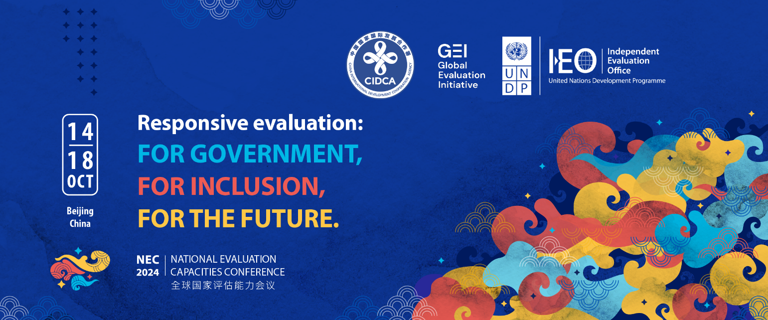

**“Responsive Evaluation: For Government, For Inclusions, For the Future”**

**Call for abstracts**

(May 2024)

# Annex 2: Abstract submission template (to be uploaded to the submission portal)

|  |  |
| --- | --- |
| Presenter’s full name (title, name, surname) | Mr. Marco Segone |
| Nationality | Italian |
| Gender | Male |
| Country of residence | USA |
| Institutional affiliation | UNFPA Independent Evaluation Office |
| Contact information including email and telephone | [segone@unfpa.org](mailto:segone@unfpa.org) +19173792575 |
| Title of the abstract | Best practices for the meaningful engagement of youth in evaluation |
| Conference session | □ Stream A. Responsive National Evaluation Systems  □ **X** Stream B. Inclusive National Evaluation Systems  □ Stream C. Future Driven Systems and Approaches |
| Name(s), title(s) and institutional affiliation(s) of all other authors/contributors (if applicable) | Panelists of the session:  Marco Segone, Director, UNFPA IEO  Erdenechimeg (Chimgee) Ulziisuren, President, Mongolian Evaluation Association  Abinash Dash, Director (Evaluation), DMEO, NITI Aayog, Government of India |
| Preferred format: | □ Formal presentation (maximum 10 minutes)  □ Participation in a panel discussion where the experience can be shared  □ **X** Participation in an interactive session where the example can be shared, without a formal presentation  □ Other (please specify) ____________________ |
| I will need to apply for bursary support, if selected. | □ Yes  □ **X** No, perhaps some panelists might need bursary support. |
| Language to be used for presentation | □ **X** English □ French □ Spanish □ Chinese |

**Abstract Text (max. 500 words)**

|  |
| --- |
| With the world population younger than ever before, meaningful engagement of youth in evaluation can turbocharge the transformative power of evaluation. This can help get the SDGs back on track. The United Nations Secretary-General’s *Our Common Agenda* emphasizes the need for intergenerational solidarity across all spheres to address the complex and interconnected global crises we face today. Youth play a vital role in identifying new solutions that can secure the breakthroughs necessary for fast-tracking the delivery of the SDGs. However, when it comes to participation in accountability processes, public policymaking and decision-making, youth remain largely invisible.  Meaningful youth engagement in evaluation offers an opportunity to reflect on development interventions from the perspective of young people themselves, ensuring that these interventions are responsive to their needs. By amplifying youth voice and agency, meaningful youth engagement in evaluation leads to positive development outcomes. It also enhances their technical and leadership capacities in evaluation and strengthens national evaluation capacities. Engaging young people in evaluation recognizes them as change-makers and leaders in building a more sustainable and inclusive world. When empowered in evaluation, youth drive innovation, introduce new ways of working, improve the relevance, credibility and usefulness of evaluations – and ultimately augment the power of evaluation to transform people’s lives.  To promote youth engagement in evaluation, the Youth in Evaluation initiative was launched in 2022 in collaboration with EvalYouth network and other stakeholders. As a dedicated priority stream of the Eval4Action campaign it aims to amplify the global momentum and commitment to meaningful engagement of youth and young evaluators in evaluation. The launch also marked the release of the Youth in Evaluation manifesto, available in six languages, which serves as an intergenerational call to action for enhancing meaningful youth engagement in evaluation. To provide a tangible framework for delivering on the manifesto’s commitments, Eval4Action facilitated an inclusive and intergenerational process to co-create standards for enhancing meaningful youth engagement in evaluation.  The standards are useful tools for interested institutions, evaluation commissioners, evaluation managers and evaluators to enhance meaningful youth engagement in their evaluation practices. In particular, the standards provide guidance and pathways for academia, governments, international organizations, private sector, VOPEs and youth organizations to initiate and advance the meaningful engagement of youth in evaluation. The stakeholders are to annually self-assess standards to understand the status of the organization and to identify best practices in terms of engaging youth in evaluation. 45 organizations from five stakeholder groups conducted self-assessments for the first time in 2024 of whom 20 organizations were selected for champion awards. Champions were selected to recognize their performance on meaningful engagement of youth in evaluation and cross fertilize best practices for greater uptake of standards. The selected organizations receive champion awards during the Youth in Evaluation week 2024.  **​**  The panel will bring a diverse group of stakeholders on sharing best practices on use of the standards for engaging youth in evaluation, including how to advance its uptake and overcome challenges in engaging youth meaningfully in the evaluation process. |