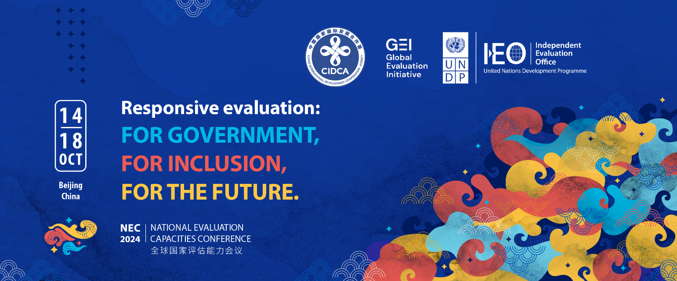

**“Responsive Evaluation: For Government, For Inclusions, For the Future”**

**Call for abstracts**

May 2024)

**ABSTRACT SUBMISSION TEMPLATE**

|  |  |
| --- | --- |
| Presenter’s full name (title, name, surname) | Serge Eric Yakeu Djiam |
| Nationality | Cameroon |
| Gender | Male |
| Country of residence | Canada |
| Institutional affiliation | EvalIndigenous Network |
| Contact information including email and telephone | +1 819 635 7974  Serge.eric01@gmail.com |
| Title of the abstract | Embedding Indigenous Evaluation Principles in National Evaluation System |
| Conference session | □ Stream A. Responsive National Evaluation Systems  ***□ Stream B. Inclusive National Evaluation Systems***  □ Stream C. Future Driven Systems and Approaches |
| Name(s), title(s) and institutional affiliation(s) of all other authors/contributors (if applicable) | Fiona Cram, Co-Chair, EvalIndigenous Network |
| Preferred format: | □ Formal presentation (maximum 10 minutes)  ***□ Participation in a panel discussion where the experience can be shared***  ***□ Participation in an interactive session where the example can be shared, without a formal presentation***  □ Other (please specify) ____________________ |
| I will need to apply for bursary support, if selected. | ***□ Yes***  □ No |
| Language to be used for presentation | ***□ English*** |

**Abstract Text (max. 500 words)**

|  |
| --- |
| EvalIndigenous is a network of Indigenous evaluators and non-Indigenous allies focused on raising the profile of Indigenous evaluation so it can be increasingly inclusive of Indigenous evaluators, Indigenous peoples, and Indigenous aspirations for equity, fairness and justice. The [United Nations Declaration on the Rights of Indigenous Peoples (2007)](http://www.un.org/esa/socdev/unpfii/documents/DRIPS_en.pdf) frames our work, moving from an evidence-based focus towards a shared global understanding of good practice for Indigenous peoples and our rights within the field of evaluation.  This abstract aims to present the indigenous principles and evaluation practices developed by “EvalIndigenous”, an EvalPartners’ network initiative, whose mandate is to support the 2030 SDGs’ agenda under a strong commitment of “Leaving no one behind” and “reaching the furthest behind first”. The objective is to contribute in embedding “Indigenous evaluation principles” in “National Evaluation Systems” worldwide. The session will highlight key achievements of EvalIndigenous as well as emerging challenges and perspectives in the loop of the “*Indexing and promoting indigenous approaches in the service of equity-centered evaluation*” project in Africa, Asia, Central and South America; with linkage to the agenda 2030. Through interactive discussion and diverse Indigenous perspective storytelling, the presenter will also share emerging social, economic and political indicators of the implementation of the 2030 Agenda and application to UNDRIP and other national/regional VOPE or community initiatives.This is also an opportunity to collectively support the growth and acknowledgement of indigenous evaluative theory and practice for an inclusive and responsive national evaluation system. |