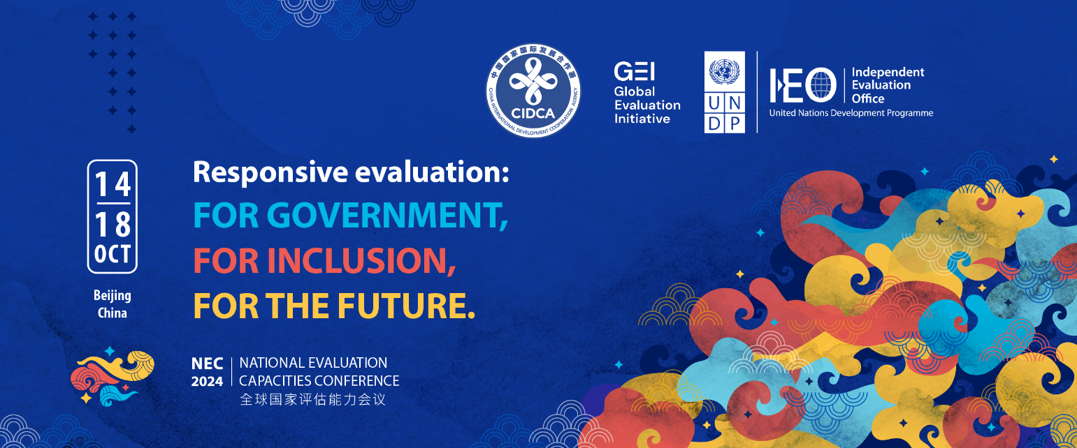

|  |  |
| --- | --- |
| Presenter’s full name (title, name, surname) | Dr Takunda J Chirau |
| Nationality | Zimbabwean |
| Gender | Male |
| Country of residence | South Africa |
| Institutional affiliation | Centre for Learning on Evaluation and Results Anglophone Africa (CLEAR-AA), Global Evaluation Initiative (GEI) |
| Contact information including email and telephone | +27610854533  takunda.chirau@wits.ac.za |
| Title of the abstract | Building National Evaluation Systems for Adaptive Management. The Cases of the United Republic of Tanzania and Republic of Uganda |
| Conference session | **X Stream A. Responsive National Evaluation Systems**  □ Stream B. Inclusive National Evaluation Systems  □ Stream C. Future Driven Systems and Approaches |
| Name(s), title(s) and institutional affiliation(s) of all other authors/contributors (if applicable) | 1. Ms Sakina Bakari Mwinyimkuu (Department of Performance Monitoring and Evaluation – Prime Minister Office: Policy, Parliament and Coordination Tanzania) 2. Ms Meema Noel Kilembe (Department of Performance Monitoring and Evaluation – Prime Minister Office: Policy, Parliament and Coordination Tanzania) 3. Mr Thomas Lazima Saguda (Director M&E,Ministry of Foreign Affairs, Tanzania) 4. Mr Timothy Lubanga (Commissioner, Directorate Monitoring, Evaluation and Inspection, Office of Prime Minister, Uganda) |
| Preferred format: | □ Formal presentation (maximum 10 minutes)  **X Participation in a panel discussion where the experience can be shared**  □ Participation in an interactive session where the example can be shared, without a formal presentation  □ Other (please specify) ____________________ |
| I will need to apply for bursary support, if selected. | X Yes  □ No |
| Language to be used for presentation | X English □ French □ Spanish □ Chinese |

**Abstract Text (max. 500 words)**

|  |
| --- |
| Achieving medium and long term development plans in Tanzania (Five Year Development Plan -FYDP & Vision 2025-2050), Uganda (National Development Plan and Vision 2040), AU Agenda 2063 and Sustainable Development Goals (SGDs) requires robust and functional National Evaluation Systems (NESs). Building and or strengthening NESs that are country led, focused and owned is more than important. In Tanzania, the Prime Minister’s Office Policy, Parliament and Coordination – Performance Monitoring and Evaluation Division is the custodian of the NES while in Uganda, it is the Office of the Prime Minister – Directorate of Monitoring Evaluation and Inspection (DMEI). The Global Evaluation Initiative (GEI) through the Centre for Learning on Evaluation and Results Anglophone Africa (CLEAR-AA) is implementing two (2) country programmes in Tanzania and Uganda (East Africa). The work is centered primarily on developing evaluation infrastructure that aids the implementation of the NESs in both countries. In Tanzania, the work is on developing the national evaluation plan and, national evaluation guideline or manual and conducting national evaluation capacity readiness assessment. In Uganda, the work is on developing a national evaluation plan constituting of 20 programmes, reviewing the national public sector monitoring and evaluation policy and conducting individual M&E capacity assessment. Effective evaluation systems are dependent on evaluation policies, guidelines and plans for framing the purpose, responsibilities, and organisation of the public sector evaluation function. This ultimately contributes to better evidence generated for decision and policy making, transparency and accountability. The objective of this panel is to describe and explain the on-going Evaluation Capacity Development (ECD) support rendered by the Global Evaluation Initiative and CLEAR-AA to two countries of Uganda and Tanzania to strengthen their NESs. The subsidiary objectives of the panel are to explain: (i) How is evaluation institutional capacity being strengthened to support evidence informed policy and decision making? (ii) How can evaluation evidence be effectively utilized to support adaptive management in dynamic and complex environments? (iii) What are the key challenges and solutions in using evaluation evidence to inform adaptive management in public sector programs? Although the issues of NESs are quite substantial globally, and in relation with Africa, there is a dearth of empirical data that showcases how NESs are contributing to adaptive management and ensuring achievement of countries medium- and long-term plans, AU Agenda 2063 and SDGs. Therefore, this panel seeks to fill this important empirical lacuna and contributes meaningfully on ongoing and complex questions and debates about how to build or strengthen NESs that can aid in addressing issues of evidence use, and adaptive management.  **Word count: 417** |