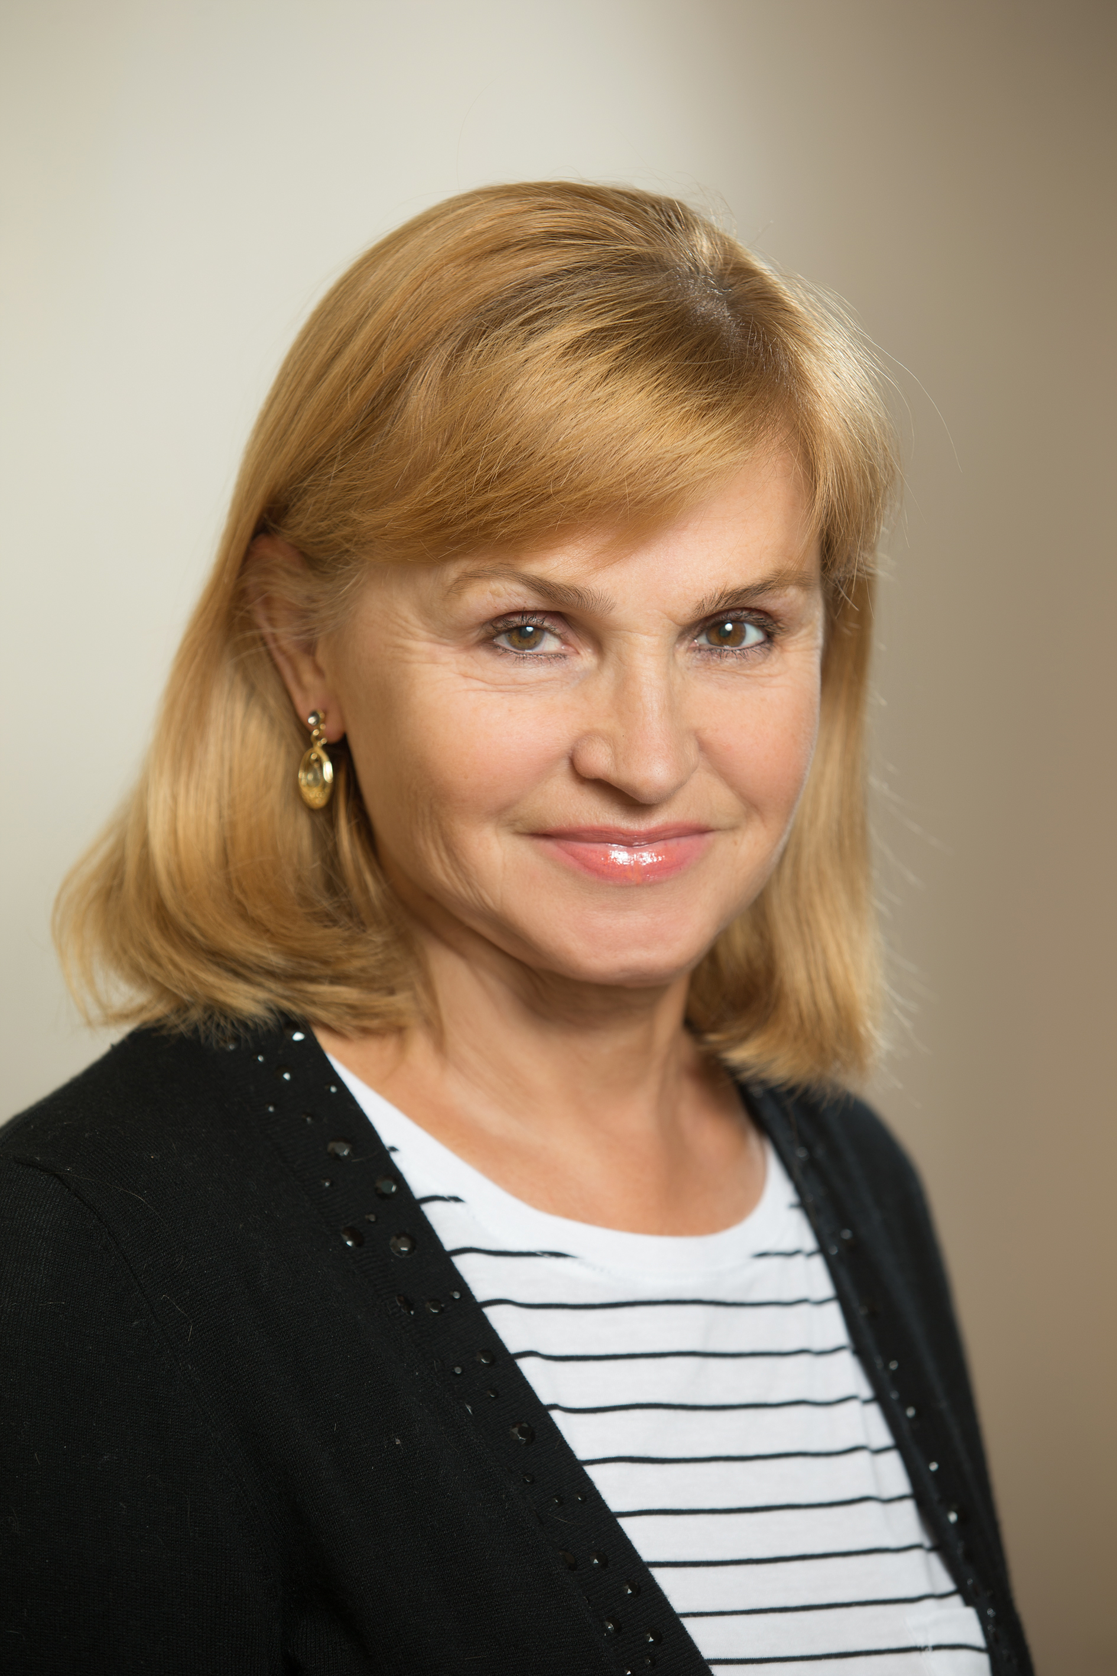
VLADYKO LIUDMILA
Education -Mathematician (Krasnoyarsk State Pedagogical University)
Since 1998, she has worked in non-profit sector development programs.
From 2001 to 2017, she worked in the public authorities of the Krasnoyarsk Territory, developed and implemented the Law of the region "On job quotas for the disabled", supervised the direction "Entrepreneurial activity of public organizations of the disabled", participated in the implementation of the Law of the Krasnoyarsk Territory "On regional social grants".
From 2005 to 2017 – Executive Secretary of the Council for Regional Social Grants of the regional grant program of the Krasnoyarsk Territory "Social Partnership for Development". Program coordination, evaluation and monitoring of the Program, Impact Assessment.
2017 - present - Co-founder, Executive Director of the regional Association of Social Entrepreneurship "Development and Management of Social strategic Alliances"
Areas of activity: development of social entrepreneurship, charity, social partnership, social design, evaluation of social projects and programs, strategic development of non-profit organizations, grant management, Member of the Association of Specialists in the Evaluation of Programs and Policies of ASOPP.
Certificates of trainings and conferences on the evaluation of social programs and projects 2005-2023.
Certificate of the Siberian Federal University advanced training -"Project Management".
Certificate of the 4th International Conference on National Evaluation Capacities (NEC) Sao Paulo, Brazil; Certificate of advanced training in the program "Project Management in the field of social entrepreneurship", Graduate School of Management, St. Petersburg State University, (2013-2014), etc.
Developer of a system for monitoring and evaluating the impact of the Krasnoyarsk Territory state grant program.
Program development-«Participation of community groups and leaders of social change in the evaluation Goverment's of programs and projects for the development of territories»

